1. Download the SaaSToolkit.zip and extract.
2. Run the Client Side Registration or TDConnectivity installation to install OTA.
3. Bring up Excel and specify the users you want to add to projects. The format is as followed:

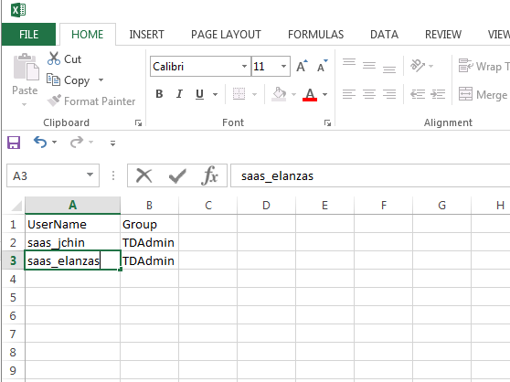

Note: Keep the excel sheet title as “Sheet1”

1. Start the SaaSToolKit.exe
2. Enter the URL. Click “Initalize Server”
3. Enter credential and password. Click “Authenticate”
4. Select your domain(s). Click on “Select Domain(s)”
5. Select your project(s). Click on “Select Project(s)”
6. Select “Add Users to Projects” from the Select Task dropdown.
7. Click on “Run”
8. An “Add users to Projects” dialog will be displayed. Enter the path of your excel file (step 2) containing list of users to import.

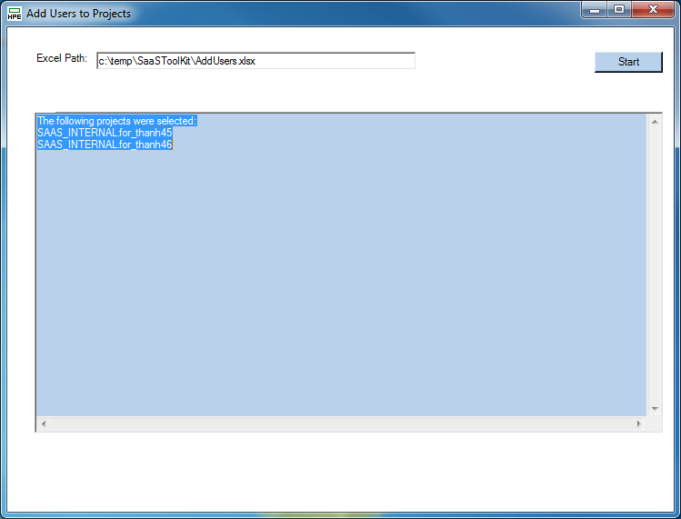

1. Click “Start”
2. Output will be displayed in the dialog window and log file.

Notes and Limitations:

1. User account used for running the tool needs to have permission to add users to the selected projects. If you don’t have enough permission then the following error will be returned:

“You do not have the required permissions to get customization object.”

1. Users to be added need to already exist in the instance. Tool will not be able to add new users to the ALM instance. If you need to add new users, then please add them through the ALM Administration Addon. The following error will be returned if user does not exist in instance:

“User does not exist in Site Admin. Please add user to instance first.”